Part 6: Complete Streets Intersection and Street Crossing Toolbox
Well-designed intersection geometry is another vital component to creating a Complete Street network that is safe, comfortable, and accessible to all modes of transportation. This section provides guidance on unsignalized and signalized intersections, as well as midblock or unsignalized crossings. The intersection types show variations in the Intersection Control Area (blue), and the signalized intersection guidance refers generally to the Approach Area (yellow).

Signalized Intersections
Signalized intersections are intersections which are controlled by traffic signals that direct the flow of all street users through the intersection. The warrants and needs for traffic signals are detailed in the Maryland MUTCD. While the Maryland MUTCD traffic volume warrants should be analyzed, meeting volume warrants shall not be the only deciding criteria for traffic signal placement. Factors to assess the need for signalization of a crossing shall include but not be limited to:
  - Engineering judgment
  - The safety of people of all ages and abilities in using an unsignalized crossing
  - Sightlines
  - Adjacent or nearby land use
  - Consistency in signal placement along a corridor
  - Speed control/maintaining platoons
  - Driver behavior in yielding/stopping for pedestrians
  - Crash history at the intersection and along the corridor. Crash history/trends at similar intersections and corridors of similar street type, street width, and adjacent land use.

The volume of pedestrians and cyclists through the intersection needs to be considered to determine the pedestrian and bicycle treatments that will be installed at the intersection.
Consider the location of the intersection in relation to potential conflicts (railroad crossings, schools, etc.) to determine which warrants can be met.
- Refer to the Maryland MUTCD for standards on signalized intersections.
- Pavement markings at signalized intersections shall be designed in accordance with the Maryland MUTCD.
- Ensure streetlighting is strategically located to illuminate a Vulnerable Traveler Zone, using cobra-style fixtures to best illuminate the zone.

This following section outlines intersection treatments which can be implemented to create Complete Streets that are safe and accessible to all users. The treatment types have been categorized by zone within the intersection.

Clear Zone Guidance
This zone represents the area approaching the intersection that is utilized to maximize vulnerable traveler visibility and vehicle flow. The area must be clear of visual obstructions, possess designations on the vehicle travelway for turning movements, bicycle accommodations, and other MUTCD signing and markings requirements.

Visibility of Vulnerable Travelers
Curb space use and other visual obstructions must be restricted as defined in the Town Code to maximize the sight distance for drivers as vehicles approach an intersection to reduce the risk of a crash between all users of the intersection. Town Code Section 28 – 1008 Visibility at Intersections addresses the safety-related restrictions.

Within the Town, it is unlawful to park any vehicle on any street within 15 feet of an intersection, unless otherwise indicated by painted line or symbol.

The following content describes the Complete Streets multimodal lane designations.

Combined Bike Lane / Turn Lane
A combined bike lane/turn lane is an area where cyclists and right-turning motor vehicles merge into one travel lane approaching an intersection. They work best at intersections with lower turning volumes, where on street parking is not provided, or where constrained right-of-way prohibits the width for a dedicated bike lane through the intersection.
Guidance
- Combined bike lane/turn lanes can be used at intersections with lower turning volumes.
- Provide a 60’ minimum merge area between the end of the bike lane and the right turn bay.
- Provide a 25’ minimum, 50’ desirable right turn bay.
- BEGIN RIGHT TURN LANE and YIELD TO BIKES signs should be located at the beginning of the merge area.
- Sharrow pavement markings should be provided in the merge area and the turn bay.
- Combined bike lane/turn lanes should be designed in accordance with the current editions of the AASHTO Guide for Development of Bicycle Facilities, Maryland MUTCD and the latest NACTO Urban Bikeway Design Guide.
- To achieve a higher bicycle level of comfort and higher ridership of the bicycle facility, separated bicycle facilities should be considered.

Through Bike Lane
Through bike lanes provide a bicycle lane to the left of right-turn lanes or to the right of left-turn lanes. With this configuration, turning motor vehicles must yield to cyclists in the bike lane. This configuration only results when dedicated turn lanes begin (lane additions) and is more typical of suburban roadways.
Guidance
  - The separated bike lane should terminate as close to the intersection as possible.
  - This treatment can be used in conjunction with bike boxes or two-stage left bicycle turn boxes.
- Provide a 60’ minimum merge area for turning vehicles to cross over the bike lane.
- Provide a 25’ minimum, 50’ desirable bike lane between the merge area and the stop bar.
- BEGIN RIGHT TURN LANE and YIELD TO BIKES signs should be located at the beginning of the merge area.
- Green paint should be used at a minimum in the merging area on higher volume facilities.
- Green paint should be in the merging area at a minimum.
- Through bike lanes shall comply with Maryland MUTCD Figure 9C-4 or 9C-5 and should be designed in accordance with the current editions of the AASHTO Guide for Development of Bicycle Facilities, NACTO Urban Bikeway Design Guide and the FHWA Separated Bike Lane Planning and Design Guide.

Lateral Shift Transitions
Lateral shifts transition cyclists from a separated bike lane to a traditional bike lane left of the motor vehicle right turn lane before vehicles can turn right. With this configuration, right-turning motor vehicles must yield to cyclists in the bike lane. Protected Intersections are preferred over lateral shift transitions since they provide increased safety, comfort and efficiency. However, lateral shift transitions may be used as an interim solution or if right-of-way is prohibitive.
Guidance
- The separated bike lane should terminate as close to the intersection as possible.
- This treatment can be used in conjunction with bike boxes or two-stage left bicycle turn boxes.
- Provide a 20’ minimum taper length for the transition between a protected bike lane and a traditional bike lane.
- Provide a 30’ minimum merge area for right turn vehicles to cross over the bike lane.
- Provide a 25’ minimum, 50’ desirable bike lane between the merge area and the stop bar.
- BEGIN RIGHT TURN LANE and YIELD TO BIKES signs should be located at the beginning of the merge area.
- Lateral shift transitions should be designed in accordance with the current editions of the AASHTO Guide for Development of Bicycle Facilities, FHWA Separated Bike Lane Planning and Design Guide and NACTO Urban Bikeway Design Guide.

Protected / Separated Bike Lane Intersection Approach
Cycle track and protected bike lane intersection approaches extend the separated bike lane up to the intersection without the use of a mixing zone. They can be installed at signalized intersections with or without dedicated vehicle turn lanes and at intersections without conflicting turning movements.

Guidance
- The separated bike lane should terminate at the vehicle stop lane.
- This treatment can be used in conjunction with two-stage left bicycle turn boxes.
- Signal detection for bicyclists should be provided if the signal is actuated.
- Provide a 1’ minimum buffer between the turn lane and the separated bike lane.
- If no dedicated turn lane is present, bicycles may use a pedestrian walk signal. A TURNING VEHICLES YIELD TO BIKES sign should be placed on the mast arm.
- NO TURN ON RED signs shall be installed.
- See the Crosswalk Marking section for guidance on enhancing the bike lane through the intersection.
- Lateral shift transitions should be designed in accordance with the current editions of the AASHTO Guide for Development of Bicycle Facilities, FHWA Separated Bike Lane Planning and Design Guide and NACTO Urban Bikeway Design Guide.

PROWAG Requirements for Protected Bike Lane Approaches
Where separated bike lanes approach intersections, the pedestrian access route must maintain a continuous 48-inch minimum clear width. The cross slope of the pedestrian access route shall be 2.1% maximum. Where the bike lane is adjacent to the pedestrian access route, appropriate edge protection or detectable warning delineators may be required to maintain clear wayfinding for pedestrians with visual disabilities.

Mixing Zone
Mixing zones are areas where cyclists and right-turning motor vehicles merge into one travel lane approaching an intersection. They work best at intersections with lower turning volumes, where on street parking is not provided, or where constrained right-of-way prohibits the width for a dedicated bike lane through the intersection.
Guidance
- Mixing zones can be used at intersections with lower turning volumes.
- Provide a 60’ minimum merge area between the end of the protected bike lane and the right turn bay.
- Provide a 25’ minimum, 50’ desirable right turn bay.
- BEGIN RIGHT TURN LANE and YIELD TO BIKES signs should be located at the beginning of the merge area.
- Sharrow pavement markings should be provided in the merge area and the turn bay.
- Mixing zones should be designed in accordance with the current editions of the AASHTO Guide for Development of Bicycle Facilities, FHWA Separated Bike Lane Planning and Design Guide and NACTO Urban Bikeway Design Guide.

Vulnerable Traveler Zone Enhancements

PROWAG Overview
The Public Right-of-Way Accessibility Guidelines (PROWAG) establish federal accessibility standards for pedestrian facilities in the public right-of-way. All intersection treatments described in this chapter should comply with PROWAG requirements to ensure safe, accessible travel for people of all ages and abilities. A majority of the guidelines apply to the Vulnerable Traveler Zone.
Core PROWAG requirements for intersection design include maintaining a continuous 48-inch minimum clear width for pedestrian access routes, limiting running slopes to 5% maximum and cross slopes to 2.1% maximum, and providing firm, stable, slip-resistant surfaces. Curb ramps must meet specific technical standards including 8.3% maximum running slope, proper landing areas, and detectable warning surfaces. At intersections where bicycle facilities intersect with pedestrian routes, clear separation and wayfinding elements are required to ensure accessibility for people with visual disabilities.
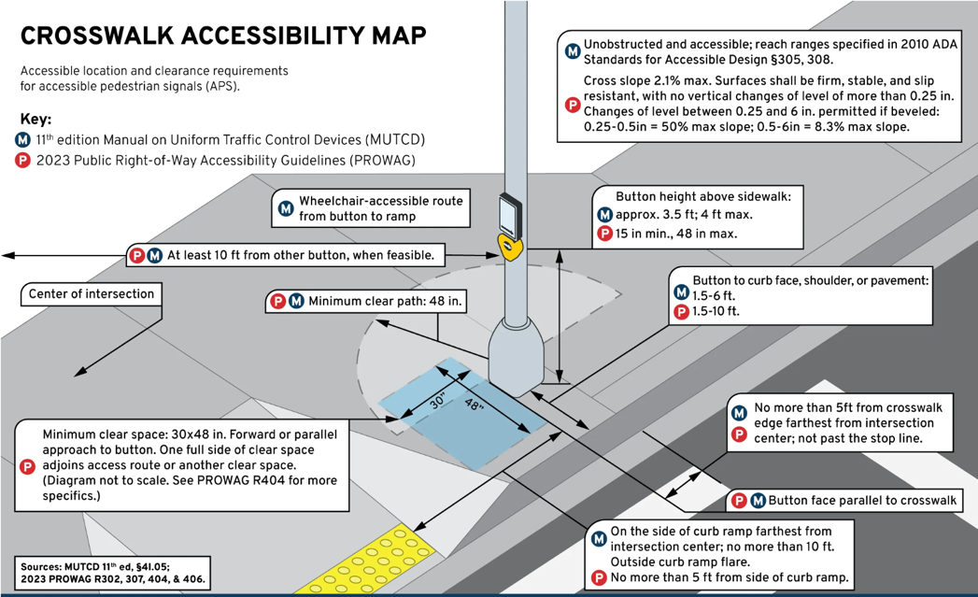
Detailed PROWAG requirements, including technical specifications, process flows for determining when PROWAG compliance is required, checklists for field verification, etc. are provided in Appendix [X]. These resources guide engineers and inspectors through the application of PROWAG standards to ensure all Complete Streets intersection improvements meet federal accessibility requirements.
Source: polara.com

Crossing Placement and Markings
Crosswalks are pavement markings that identify pedestrian and/or bicycle crossings at an intersection. Crossings including sidewalk ramps and crosswalk markings should be placed at all legs of all signalized intersections.
Guidance
- Lighting should be evaluated at all new or reconstructed crosswalks, ensuring illumination at all crossings.
- Crosswalk markings shall be the continental style at a minimum 10’ width.
- Crosswalk lines should typically extend to 1’ from the extended curb line of the intersecting street.
- Aligning crosswalks with the pedestrian desire lines is critical. Crosswalks of 30’ or more can be appropriate to match the pedestrian desire lines when crossings are adjacent to wide sidewalks.
- The stop bar should have a minimum 8’ offset from the crosswalk, with a minimum 4’ applied only under special circumstances with approval from the Town Engineer.
- For signalized intersections on the transit and truck routes, the stop bar may need to be set back up to 20’ or more to accommodate turning movements. In these cases, widening the crosswalk to decrease the gap between the crosswalk and the stop bar should be considered to prevent drivers from ignoring the set-back stop bar.
- All legs of a signalized intersection must have marked crosswalks.
- Bicycle intersection crosswalk markings should use dotted line extensions of 12-inch-wide lines at 12 inch spacing and be enhanced with solid green pavement marking.

Sidewalk Ramps
Guidance
- Wider sidewalk ramps should be provided in areas with higher pedestrian volumes or on shared-use-paths.
  - The width of the ramp should match the width of a shared-use path.
- Street lighting should be evaluated at all new or reconstructed sidewalk ramps.
- Sidewalk ramps shall comply with Town and State standards.
- Sidewalk ramps on opposing sides of the street should line-up with each other, unless pedestrian desire lines would recommend alternative.
- The entire width of the sidewalk ramp must be contained within the crosswalk.
- Sidewalk ramps do not need to be centered within crosswalks. A wider crosswalk that better aligns with pedestrian desire lines may often require off-center sidewalk ramps.
- Sidewalk ramps shall not lead a pedestrian, cyclist or other micro-mobility user to a stormwater inlet.
- A single ramp should not be used for two crosswalks at the corner of an intersection (except on a shared street). If there are conflicts in the Curb Buffer Zone, such as utilities that prevent the construction of two curb ramps, the following strategies can be implemented:
    - Curb extensions can be used to provide the space for two ramps in front of conflicts. If drainage cannot be reconfigured, consider the use of slot drains to maintain the existing drainage pattern.
    - Interim corner extensions or bump outs that use low-cost materials may also be considered on a case-by-case basis.
      - Interim corner extensions consist of a white thermoplastic edge line and bollards or flexible post delineators (flex posts) to serve a similar function to a curb. The use of truffle colored treatment and detectible warning surfaces should also be considered when this treatment is applied.
    - Offset/setback pedestrian ramps can also be considered where the crosswalks aren't centered, but rather placed in a normal path that aligns with pedestrian desire lines.
- Detectable warning surfaces shall comply with Town and State standards.

PROWAG Requirements for Sidewalk Ramps:
Curb ramp types include perpendicular ramps, parallel ramps, and blended transitions. The selection of ramp type should be based on available space, sidewalk width, and site constraints.
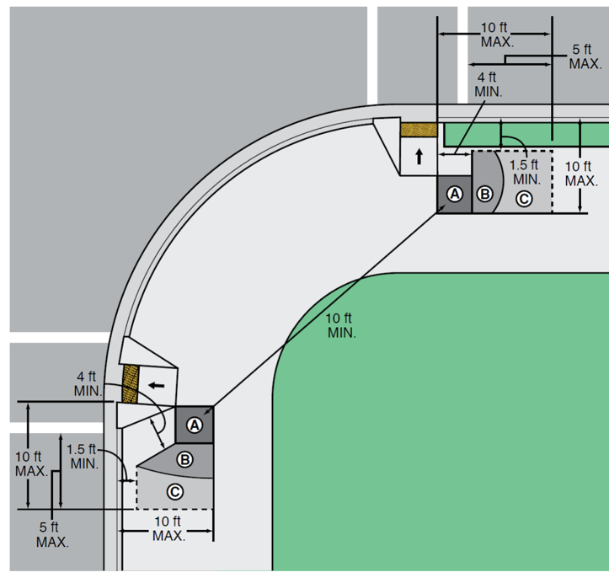

Curb Extensions
Curb extensions visually and physically narrow the roadway width at intersections or mid-block crossings. This creates a shorter pedestrian crossing and narrower physical lane width that can slow vehicle speeds and improve sight lines between pedestrians and vehicles. The space that is gained can be used to increase the sidewalk Curb Buffer Zone.
Guidance
- Pedestrian curb extensions are appropriate in any Street Type in which the curb extensions do not interfere with the use of the curb space or bicycle lane operation.
- Drainage should be evaluated for all curb extension installations.
- Installation of curb extensions may require moving fire hydrants to maintain adequate curb-side access.
- Curb extensions are ideal locations for in-lane bus stops, known as bus bulbs.
- The methods of installation include quick build /interim techniques or permanent configurations.
- The location where the curb transitions to the full width of the roadway shall be a minimum of 10’ from the crosswalk, where feasible.
- The curb extension cannot extend into travel lanes and can encroach only on parking lanes or other non-travel road space.
- Green stormwater infrastructure plantings in curb extensions should not reach more than 24” in height at full maturity so not to impede on sight distance.

Pedestrian Safety Island
Pedestrian safety islands are raised or protected areas in the center of the street at intersections or at mid-block crossings. By providing a place to wait mid-crossing, pedestrian safety islands allow pedestrians and cyclists to navigate one direction of motor vehicle travel at a time. They also have been shown to reduce pedestrian crashes by up to 56% (FHWA-SA-17-064). Pedestrian safety islands are highly recommended at intersections with high speeds and volumes that make pedestrian or bicycle crossings prohibitive, or where two or more motor vehicle lanes increase exposure.
Guidance
- Pedestrian safety islands are appropriate as interim or permanent measures in any multi-lane roadway with high traffic volumes.
- When installing pedestrian safety islands at intersections, the turning movements for the designated design and control vehicles should be modeled to verify there are no conflicts.
- On streets with center turn lanes, pedestrian safety islands can be used on the side of an intersection that does not have a left turn movement.
- Appropriate lighting levels should be provided for the pedestrian safety island.
- Consider the use of green stormwater or landscaping treatments within the pedestrian safety island.
- The cut-through width should equal the width of the crosswalk on high volume pedestrian crossings. At lower volume crossings, the cut-through area must be a minimum 5’ wide, while the crosswalk would be striped wider.
- The desired width of a pedestrian safety island is 8’ to 10’. The minimum width of a pedestrian safety island is 6’. If cyclists are to use the pedestrian safety island, the minimum width should be 8’.
- If provided, the sidewalk ramps in the median shall comply with Town and State standards.
- Object markers or other vertical elements are encouraged on or approaching pedestrian safety islands, especially when a lane shift vehicular approaches occurs in advance of the island.

Bicycle Lane Intersection Treatments
Bicycle lanes at intersections provide cyclists and other micromobility users facilities that are visually separated with paint from vehicle travel lanes. For additional information and design guidance beyond this manual, see NACTO’s Don’t Give Up at the Intersection.

Bicycle Box
Bicycle boxes provide a space in front of the motor vehicle stop bar for cyclists to queue at a red light. They give cyclists a head start in front of vehicles when a traffic signal turns from a red phase to a green phase, which reduces conflicts between bicycles and motor vehicles.

Guidance
- Bicycle boxes should not extend across more than one through lane. For wider intersections with more vehicle lanes, consider the use of a two-stage left bicycle turn box.
- Bicycle boxes should be 10’ minimum in depth and be the full width of the bicycle lane and adjacent general-purpose travel lane.
- Bicycle boxes can extend a maximum of one through lane and one left turn lane.
- An ingress bicycle lane of 25’ to 50’ should be provided prior to the intersection.
- The bicycle box design should follow guidance in the current editions of the AASHTO Guide for Development of Bicycle Facilities and NACTO’s latest Urban Bikeway Design Guide.
- Green paint should be used within the bicycle box and the ingress bicycle lane.

Two-Stage Left Bicycle Turn Box
Two-stage left bicycle turn boxes improve cyclists’ level of comfort through an intersection by reducing potential conflicts between cyclists and motor vehicles. They allow cyclists in a bike lane or a separated bike lane that is right of through traffic the ability to make a left turn without having to cross by yielding to adjacent moving through or left-turn motor vehicles. This is achieved by establishing a queuing area to wait to turn at the intersection outside of the traveled path of motor vehicles and other bicycles. Cyclists proceed across the intersection upon receiving a green signal, or at unsignalized intersections when they are clear.
Guidance
- Two-stage left bicycle turn boxes are appropriate in the following Street Types
- Two-stage left bicycle turn boxes can be used at signalized and unsignalized intersections.
- Two-stage left turn bicycle turn boxes must be placed in a protected area outside of the flow of traffic.
- When implementing a two-stage left turn bike box at a signalized intersection in which the bike box is in the path of a conflicting left or right-turning vehicle, NO TURN ON RED signs shall be installed controlling that turning movement.
- Two-stage left bicycle turn boxes should be a minimum of 8’ long and 8’ wide.
- The two-stage left bicycle turn box design should follow guidance in the latest addition of the AASHTO Guide for Development of Bicycle Facilities and NACTO’s latest Urban Bikeway Design Guide.
- Green paint should be used within the box.

Control Zone
This zone of the intersection represents the area that possesses the conflicting movements of all users at the location. The Control Zone should prioritize safety first, apply treatments to manage speed and minimize user confusion (lane designations and clear signing / markings), and accommodate the variety of vehicles that routinely navigate the location. The design should align directly with the Street Types crossing at the location.

Corner Design
Street corner design directly impacts the safety and comfort of all users. Intersection design and operation must prioritize the safety and comfort of the most vulnerable road users, and as such must be designed to (1) slow vehicle speeds; (2) provide accessible and intuitive pedestrian crossings; and (3) minimize crossing distances. Minimizing crossing distances reduces conflict areas and improves the line of sight between drivers and people walking and biking across intersections.
While slower turns and shorter crossings are the priority, corners should also be designed to provide adequate turning space for the appropriate design and control vehicles. Street Types and the intersecting roadways guide the selection of the appropriate design vehicle for an intersection. As detailed in the Travelway Section, a design vehicle is a vehicle for which a street is designed to accommodate on a regular basis without great difficulty, interruption to opposing traffic flow, or other operational issues. A control vehicle is the vehicle for which a street is designed to accommodate on a rare/infrequent basis. A control vehicle may utilize multiple lanes, including opposing travel lanes on the origin and destination approaches, to complete a turn.
Curb Radius
Curb radius is the actual radius on a physically raised curb, or the radius created by delineators or other vertical elements on a flush curb.
Effective Curb Radius
Effective curb radius forms the curve which vehicles follow when turning and is increased beyond the actual curb radius when there is on-street parking, bicycle lanes, and other roadway features which push the starting or ending position of a vehicle away from the curb.
Strategies and Guidance for Optimizing Curb Radii
Optimizing curb radii slows turning vehicles, improves sightlines, and shortens crossing distances, all of which increase the safety and comfort of vulnerable users at intersections. The following strategies should be employed by designers to ensure curb radii is minimized while still serving the appropriate design and control vehicles:
In General
Set back stop bars and right-turn on red restrictions should be implemented to minimize curb radii while still accommodating the appropriate design and control vehicles. A crawl speed of less than 5 mph should be assumed for turning simulations of large vehicles on truck and transit routes. On smaller streets or access points for deliveries, a “stop and turn full lock” approach should be used in simulation of the control vehicle turn.
Low-Volume Streets
The control vehicle may swing wide and utilize the entire width of the roadway on the departing and receiving streets. Stop bar placement can be reflective of typical conditions needed for adequate sightlines, even if this interferes with large vehicle turns.
Signalized Intersections
Buses should be able to turn from the departure lane and may utilize any receiving lane to complete the turn, with attention paid to the needs of adjacent transit infrastructure. Large trucks may encroach on the lane adjacent to the right-lane from the departure street and turn into any receiving lane on the receiving street, with the swept path utilizing the entire width of the receiving street.
Deviations from Standards
Designers should follow the standards and use the strategies outlined in this section to minimize curb radii; however, the design of corner radii is unique to certain intersections based on the skew of an intersection, required deliveries influencing the control vehicle, or the presence of bicycle or transit facilities. Deviations from Town Code and the guidance in this manual must be approved by the Town’s Engineer.

Protected Intersections
Protected intersections provide a continuous separation of the bicycle, motor vehicle and pedestrian routes through the intersection. Protected intersections also shorten the bicycle crossing distance through the intersection and give cyclists a head start in front of motor vehicles on a green phase with signal timing adjustments in place.
Guidance
- It is desirable to provide enough space to allow through-moving cyclists space to pass left-turning cyclists.
- Bike yield lines are recommended on the approach to the intersection prior to the pedestrian crossing.
- While it is desirable to provide protected crossings on all quadrants of the intersection, if space is limited, or if need is not warranted, traditional bike lane crossings and/or the use of two-stage left turn boxes may be provided.
- Corner islands should be designed to accommodate design and control vehicles. Truck aprons can be implemented on corner islands to help facilitate turning movements for vehicles larger than a passenger car.
- Sight distance between through-moving cyclists and left or right-turning vehicles needs to be closely evaluated at protected intersections. 40’ of clear distance is recommended from the front of the last parking space to the point where cyclists are exposed to turning vehicles.
- See the Clear Zone Section for guidance on enhancing the bike lane through the intersection.
- Protected intersections should be designed in accordance with the current editions of the AASHTO Guide for Development of Bicycle Facilities, FHWA Separated Bike Lane Planning and Design Guide and NACTO Urban Bikeway Design Guide.
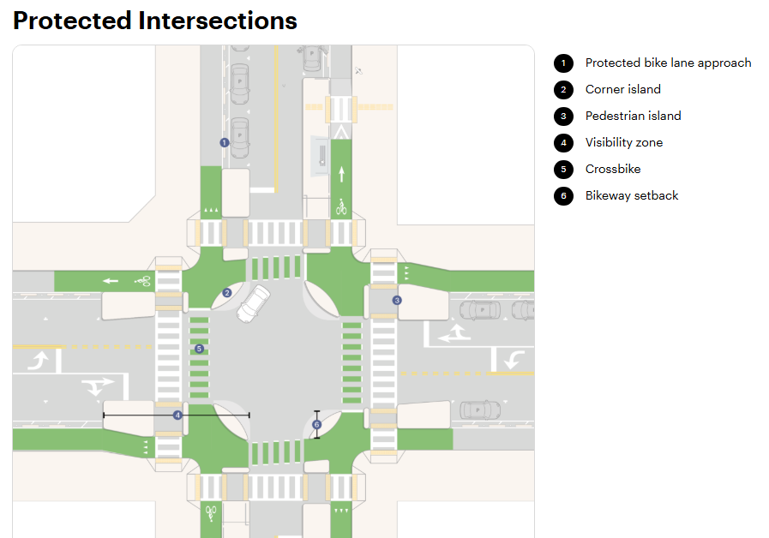

Dedicated Bike Intersections
NACTO’s Don’t Give Up at the Intersection publication uses the term dedicated bike intersections to describe intersection designs where bicycle movements are physically separated from motor vehicles and often operate with their own geometry, signals, or protected space. These designs are intended to maintain the comfort and safety of protected bike lanes through the intersection, where most crashes occur.

As detailed in Don’t Give Up at the Intersection, dedicated bike intersections include:

- Protected intersections with corner safety islands: these islands tighten vehicle turning radii, slow turning speeds, and create a protected waiting area for cyclists.
- Setback bicycle crossings that increase yielding and visibility: bicycle crossings are placed 20–30 feet back from the vehicle stop line, increasing visibility and giving drivers more time to yield.
- Dedicated bicycle signal phases: (1) leading bicycle intervals; (2) exclusive bike phases; and (3) red indications for turning vehicles.
- Fully separated bike paths through the intersection.
- Minor-street protected crossings.

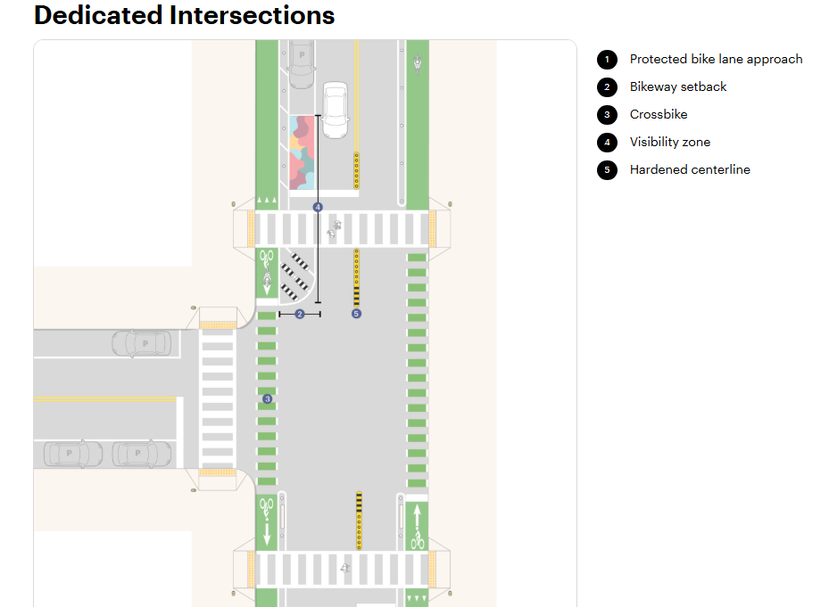

Protected / Separated Bike Lane Intersection Treatments
Separated bicycle lanes at intersections with three legs provide cyclists and other micromobility users facilities that are physically separated from vehicle travel lanes. The separation elements can include curb or other separation elements such as flexible delineators, bollards, wave delineators, raised channelizing systems, etc. Separated bicycle lanes provide an increased bicycle level of comfort to cyclists and other micromobility users within a facility. Please check the current editions of AASHTO Guide for Development of Bicycle Facilities, FHWA Separated Bike Lane Planning and Design Guide and NACTO Urban Bikeway Design Guide for the latest industry standards.
replace image

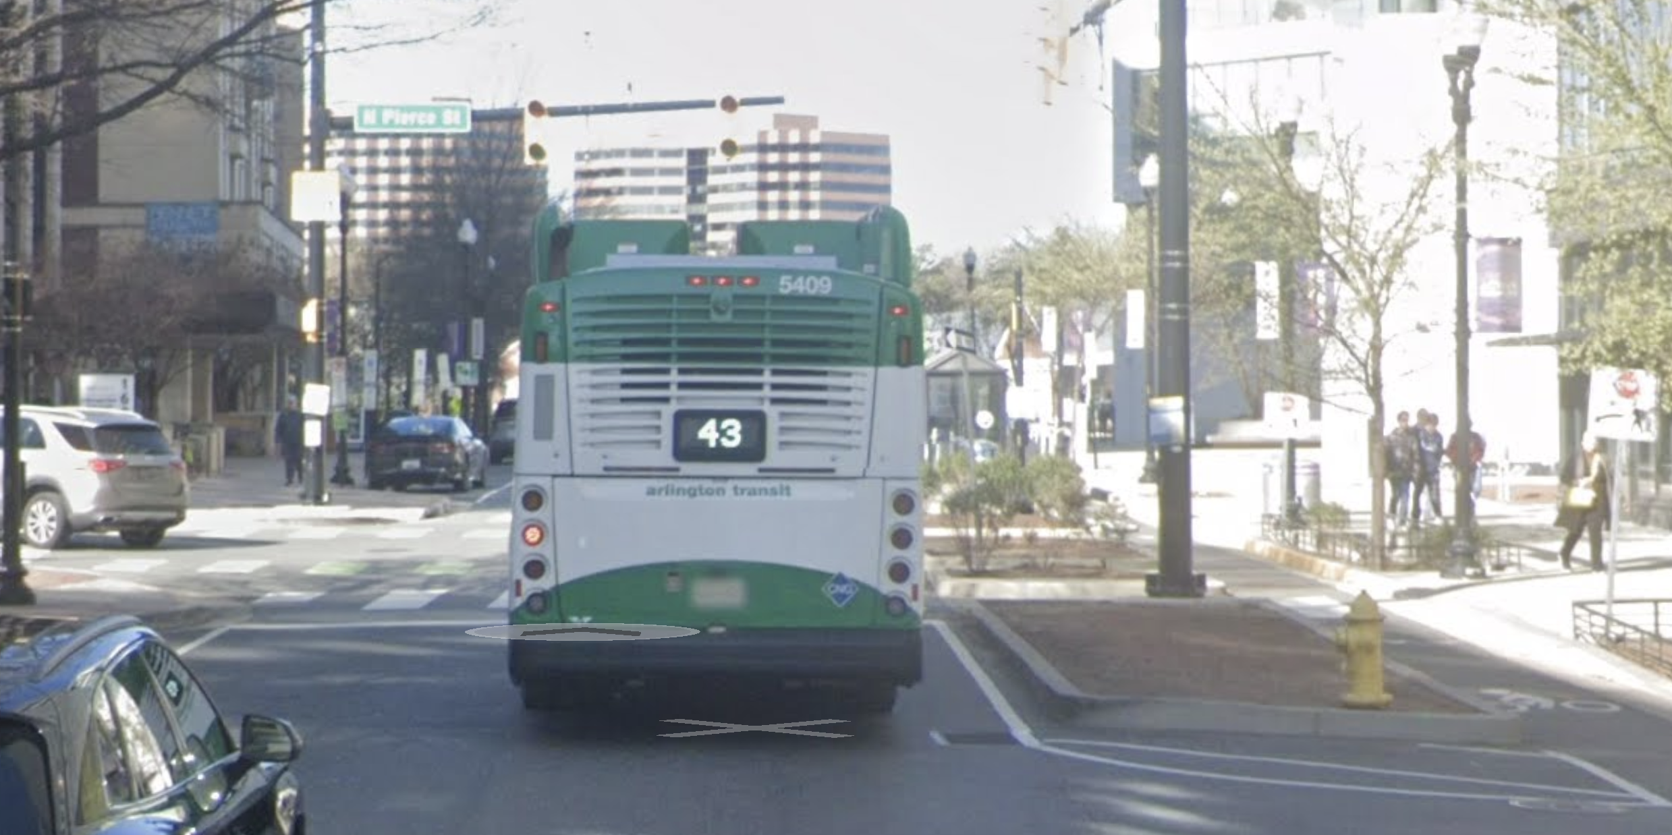

Stop Controlled Intersections
Stop controlled intersections are intersections where at least one of the approaches are controlled by a stop sign. At intersections where a minor road intersects a major road, stop signs are typically placed on the minor road. All-way stop sign application can be implemented on roadways in which sightlines are limited and minor street volumes and pedestrian volumes are significant enough to warrant a stop sign to assign them equal right of way.
Guidance:
- Sight distance should be evaluated when identifying the location of a stop sign or evaluating a request for an all-way stop. Inadequate sightlines may warrant an all-way stop or traffic signal.
- Significant parking elimination or removal of trees/landscaping features should not be the first solution for an intersection with sightline deficiencies.
- Within the grid network, consistency in all-way stop application should be a significant factor for determining placement of stop signs. If a roadway has multiple all-way stops and uncontrolled intersections are the exception, for consistency, it may make sense to install all-way stops at each intersection to better match driver and pedestrian expectations of right-of-way assignment.
- On wide roadways (approximately >35’) with stop signs, a left and right side stop sign should be provided.
- On wide roadways, increased visibility to the right side stop sign can be provided by either an in-road stop sign or a stop sign placed in a bump out.
- It is desirable to minimize the number of stop signs on bicycle boulevards.

Raised Intersections
Raised intersections provide a flat raised section of the roadway throughout the intersection. This enhances the pedestrian crossings by slowing approaching vehicles. These intersections are typically placed at the junctures of collector, local, and residential streets that have a high pedestrian crossing demand, and raise both the intersection and the crosswalks on all approaches.
Guidance
- Use at intersections with approach speeds at or less than 35 mph.
- Typically, the raised intersection is level with the adjacent sidewalk.
- Bollards may be used to assist with delineation of the roadway from the surrounding sidewalk. Control vehicle turning movements should be evaluated when placing bollards. The bollards should not be placed as to interfere with pedestrian or bicycle movement at the crossings.
- The flat area of the motorist travelway may be constructed with concrete and can be textured to differentiate it from other sections of the roadway.

Mini-Roundabouts / Neighborhood Traffic Circles
Mini-roundabouts (also called neighborhood traffic circles) are circular intersections that use textured and/or raised central islands to circulate traffic in a counterclockwise direction. This configuration slows vehicles on approach to an intersection since they are required to yield to other vehicles within the intersection. Along with slowing down vehicles, mini-roundabouts can reduce certain types of crashes that are prevalent at traditional intersections, including “T-bone” and “head-on” crashes.
Guidance
- Mini-roundabouts are typically chosen compared to full-size roundabouts with the intention of minimizing/eliminating any work outside of the existing intersection footprint.
- Pedestrian ramps and crosswalks should be placed close to the curb returns at each of the corner quadrants of the roundabout.
- A vertical element should be placed in/on the mini-roundabout to provide drivers awareness of its existence.
- Raised pavement markings or other reflective devices should be placed on the outside of a mini-roundabout to increase nighttime visibility.
- NCHRP Report 672 recommends an inscribed circle diameter of between 45’ to 90’and the use of the SU-30 as a design vehicle. However, a delivery vehicle (DL-23) may be appropriate on residential streets.
- The recommended maximum entry speed for mini-roundabouts is typically 15 mph. (NCHRP Report 672).
- Mini-roundabouts can be used as a traffic calming element.
- Mini-roundabouts can be a good opportunity for green stormwater infrastructure.
- Bicycle lanes should terminate prior to a mini-roundabout. Sharrows should be provided on the approach to the mini-roundabout.
- Mini-roundabouts should be designed in accordance with Maryland SHA Roundabout Design Guidelines and NCHRP Report 672.
- Signing and pavement markings at a mini-roundabout should be designed in accordance with the Maryland MUTCD.
- Two scenarios to allow for truck turning movements are acceptable:
    - Make the central island traversable with mountable curbs so that large turning vehicles (emergency vehicles) can mount it when turning.
    - If the central island is not traversable, trucks or larger vehicles turn left against traffic flow.
- If the splitter island is wider than 6’ (7’-4” face of curb to face of curb) then a pedestrian safety island must be provided.
- For lighting design within a mini-roundabout, refer to NCHRP Report 672.

Roundabouts
In addition to mini-roundabouts, single-lane roundabouts and multi-lane roundabouts are also design options. Some of the differences between the three types include the desirable maximum entry speed, with single-lane roundabouts being between 20 and 25 mph and multi-lane roundabouts being between 25 and 30 mph. Compared with mini-roundabouts, the size of the inscribed circle increases for roundabouts, with single-lane roundabouts having a diameter of 90’ to 180’and multi-lane roundabouts having a diameter of 150’ to 300’. Rather than the fully traversable island that is characteristically common with mini-roundabouts, the central islands in roundabouts are raised with traversable aprons. Also, the larger roundabouts can service larger volumes of traffic.
Similar to a mini-roundabout, the configuration of a roundabout slows vehicles on approach to an intersection since they are required to yield to other vehicles within the intersection. Along with slowing down vehicles, roundabouts can reduce certain types of crashes that are prevalent at traditional intersections, including “T-bone” and “head-on” crashes.
Guidance
- Given the requirement for drivers to yield to pedestrians, careful selection of roundabouts is recommended. Full-size roundabouts are typically better-performing at locations with lower pedestrian volumes.
- The recommended maximum entry speed for single-lane roundabouts is typically 20-25 mph and for multi-lane roundabouts between 25-30 mph. (NCHRP Report 672)
- Pedestrian ramps and crosswalks should be placed close to the curb returns at each of the corner quadrants of the roundabout.
- NCHRP Report 672 recommends a diameter between 90’ to 180’for single-lane roundabouts. Single-lane roundabouts should be designed so that a single unit truck can navigate the circulator road in-lane, while a tractor trailer can navigate the roundabout by utilizing the circulatory road and the truck apron. However, if the single-lane roundabout falls on a truck route, the design vehicle can utilize the truck apron.
- NCHRP Report 672 recommends a diameter between 150’ to 300’ for multi-lane roundabouts. Multi-lane roundabouts should be designed so that a single unit truck navigates the circulator road in-lane, while a tractor trailer can navigate the roundabout by utilizing the circulatory road and the truck apron. However, if the multi-lane roundabout falls on a truck route, the design vehicle can utilize the truck apron.
- Multi-lane roundabouts present challenges for pedestrians and cyclists because they must cross two lanes of uncontrolled traffic. Consider the use of rectangular rapid flashing beacons or high-intensity activated crosswalks at pedestrian crossings on multi-lane roundabouts. There are designs that could be implemented that provide a refuge island between each lane of moving traffic, but that will increase the intersection footprint.
- Conventional bicycle lanes must terminate prior to a roundabout per MUTCD. A shared-use path or cycletrack should be provided on the outside of the roundabout. See NCHRP Report 672 for guidance.
- Roundabouts shall be designed in accordance with Maryland SHA Roundabout Design Guidelines and NCHRP Report 672.
- Signing and pavement markings at a roundabout shall be designed in accordance with the Maryland MUTCD.
- Crosswalks should be placed approximately 20’ upstream of each entrance to allow for a single vehicle to be stopped between the crosswalk and the circulatory road entrance.
- If the splitter island is wider than 6’ (7’-4” face of curb to face of curb) then a pedestrian safety island must be provided. NCHRP Report 672 for further details.
- For lighting design within a roundabout, refer to NCHRP Report 672.

Median Diverters
Median diverters prevent motor vehicles from driving straight through the intersection while allowing cyclists, micromobility users, and pedestrians to continue through the intersection. They also allow cyclists, micromobility users, and pedestrians to cross the intersection in two stages.
Guidance
- Median diverters are appropriate on low volume, primarily residential streets where through traffic is not desired, but pedestrian and cyclist connectivity is critical.
- Consider the use of green stormwater infrastructure adjacent to the sidewalk and/or bike lane portion of the median diverter.
- Median diverters should be considered along bike boulevards to keep motorist volumes low and to provide crossing opportunities for cyclists along these corridors.
- If the cut-through is wider than 8’ in width, flexible post-delineators should be placed in the center of the cut-through to prevent motor vehicles from crossing through.
- The desired width of a median diverter is 8’ to 10’. The minimum width of the median diverter is 6’ (7’-4” face of curb to face of curb).
- When installing median diverters in intersections, the turning movements for the designated design and control vehicles needs to be evaluated to ensure desired access is maintained.
- Vegetated areas within the median diverter should not grow to more than 24” at full maturity.

Midblock or Unsignalized Crossing Guidance

Mid-block Crossings
Mid-block crossings can be added to the transportation network in locations that improve accessibility and safety for pedestrians / bicyclists. Accessibility can be improved by locating the crossings aligned with desired travel routes such as trail crossings, community center / school entrances, and between traffic-controlled intersections spaced beyond 400-600 ft. The crossing treatments must be compliant with the MUTCD and be validated with a safety / warrant study. The study is necessary to evaluate critical safety factors such as sight distance and fit within the existing transportation network as well as determine the appropriate crossing treatment based on the location, facility type, community context, volume of existing and planned users, and civil engineering design elements (if the treatment impacts drainage or moving curbs).

When possible mid-block crossings should be designed to include speed management tactics to reduce vulnerable traveler risk. Such tactics includes islands, curb extensions, signing, and pavement markings.

Angled pedestrian paths should be constructed at unsignalized mid-block crossings with pedestrian safety islands that are wide enough to accommodate a diagonal cut-through. The cut-through should be angled diagonally toward oncoming traffic, directing the attention of pedestrians toward approaching vehicles.

Unsignalized Intersections
Additional guidance not included in other sections:
Crossings with sidewalk ramps and crosswalk markings should be placed based on context and adjacent land use. In general, streets through residential and commercial areas should have crossings (unmarked or marked) with sidewalk ramps at all four-leg intersections. T-intersections may not correlate to pedestrian desire lines and may not require sidewalk ramps and pedestrian crossings, but should still be evaluated.
- The need for crosswalk markings is dependent on traffic volume and markings should be placed based on an engineering assessment. I.e., lower volume streets may not require any markings to facilitate safe pedestrian, bike, and vehicle movement.
- On roads with higher traffic volumes (some collectors, all arterials), a minimum of one marked crosswalk across the major street should be placed at each four-leg intersection and at major pedestrian generators, such as bus stops that are not adjacent to signalized intersections. Follow MUTCD guidelines for locating a safe crossing.
    - On streets through residential and commercial areas, at four-leg intersections, or at bus stops not adjacent to a signalized intersection, pedestrians should not be required to cross more than two lanes of traffic at a time without refuge. Potential treatments include pedestrian refuge islands / medians and lane reductions.
- Based on the guidance above, if pedestrian refuge is recommended but cannot be provided, or the roadway is only two lanes but experiences average daily traffic volumes of approximately 10,000 vehicles per day or greater, marked crosswalks are recommended for signalization, which includes:
      - Conventional signal
      - Pedestrian signal
      - Pedestrian hybrid beacon

Safety Treatments for Unsignalized intersections and Mid-block Crossings

Passive Measures
Providing passive measures such as stop signs (when warranted), pedestrian crossing signs, and striped crosswalks may be appropriate at unsignalized intersections on lower volume roads that operate at their intended target speeds. Passive measures are acceptable crossing treatments on streets that:
- Operate at a target speed of <25 mph
- Have Average Daily Traffic of < 8,000 vehicles per day
- Are only one lane in each direction

Mid-block crosswalks facilitate pedestrian crossings at locations that are not facilitated by crosswalks at nearby intersections. Representative examples that warrant a mid-block crosswalk may include transit stops, parks, plazas, building entrances, midblock passageways, trails, etc.
Guidance
- The construction of curb extensions is recommended at mid-block crosswalks. Uses for these extensions can include transit stops and green stormwater infrastructure. The construction method could also include quick-build materials, facilitating a low-cost implementation that in most cases does not impact drainage at the site.
- For guidance on the use of crosswalk safety enhancements including high-visibility crosswalk markings, raised crosswalks, advance yield here signs, in-street pedestrian crossing signs, curb extensions, pedestrian safety / refuge islands, rectangular rapid-flashing beacons, road diets, and pedestrian hybrid beacons, refer to the FHWA Guide for Improving Pedestrian Safety at Uncontrolled Crossing Locations.
- Set stop lines at midblock crossings back 20’ to 50’.
- Stripe the crosswalk regardless of the paving pattern, material, or color.
- If curb extensions cannot be constructed, limit parking to at least 20’ prior to the crosswalk.
- For lighting design within the crosswalk, refer to NCHRP Report 672.

While different measures of control may be implemented to improve pedestrian safety at currently unsignalized or mid-block crossings that align with pedestrian desire lines, pedestrian safety islands, combined with passive or active measures may increase the comfort and safety on a street that experiences higher target speeds.

Active Measures and Raised Crosswalks
Providing active measures such as Rectangular Rapid Flashing Beacons or other flashing lights, or raised crosswalks may be appropriate on medium volume roadways that operate at their intended target speeds. Active measures are acceptable crossing treatments on streets that:
- Operate at a target speed of < 25 mph
- Have Average Daily Traffic of <12,000 vehicles per day
- Are only one lane in each direction

Raised crosswalks should be limited to streets classified as secondary and local emergency access routes.

Rectangular Rapid Flashing Beacons (RRFB)
Rectangular rapid flashing beacons are also known as “Light Emitting Diode (LED) Rapid-Flash Systems”, “Stutter Flash” or “LED Beacons.” They are primarily used to supplement pedestrian warning signs at unsignalized intersections or mid-block crosswalks. RRFBs contain amber lights that use an irregular flashing pattern.
Rectangular rapid flashing beacons (RRFBs) are encouraged on mid to high volume roadways on which a pedestrian is required to cross up to two lanes at a time. However, these should not be considered an adequate substitute for signalization on higher volume multilane (3+) roadways without pedestrian refuge.
Guidance
- RRFBs are typically used at high pedestrian volume crossings or commonly used cyclist crossing routes.
- RRFBs are used primarily at mid-block crossings where signals are not used due to preference or warrant, but may be used at slip lanes, roundabouts, or other uncontrolled crossing locations.
- The RRFB can be activated by either push-button or automatic detection of pedestrians.
- Refer to the FHWA Guide for Improving Pedestrian Safety at Uncontrolled Crossing Locations for further details on selection criteria of RRFBs.
- RRFBs should be installed according to the conditions of FHWA Interim Approval 21.
- If used with pedestrian safety islands or medians, a secondary RRFB must be used.
- Beacons will be unlit when not in use.
- Ensure adequate cobra-style streetlighting meeting Town standards.

Signalized Crossings
High volume multi-lane roadways that experience higher speeds require special attention to make crossings all-ages. Both passive measures and active measures to assist in pedestrian crossings rely on driver compliance in yielding to pedestrians. In general, signalized crossings including a full-signal, pedestrian signal, or HAWK signal are recommended treatments on streets that:
- Operate at a speed of > 25 mph
- Have Average Daily Traffic of >12,000 vehicles per day
- Are multiple lanes in one direction

High-Intensity Activated crossWalK (HAWK)
Also known as a pedestrian hybrid beacons, HAWK signals are used where a standard traffic signal may not be desired, but active control is still required for pedestrian safety. HAWK beacons control the flow of traffic with two horizontal red lights over a single yellow light. When pedestrians activate the HAWK beacon, the red signal activates, which signals to traffic to come to a complete stop. The pedestrian signal which accompanies the HAWK beacon then signals to pedestrians that it is safe to cross the roadway.

Guidance
- HAWK beacons are typically used where pedestrian or bicycle facilities intersect major routes and in activity centers when a major pedestrian / cyclist crossing aligns mid-block within a Complete Streets network.
- If bicycle movements are also expected at the crossings, a bicycle signal head should also be installed along the HAWK signal.
- A standard traffic signal is typically a more appropriate treatment in the context of a Town roadway network.
- Refer to Maryland MUTCD, Chapter 4F for details on HAWK installation.
- HAWK signal faces are placed in pairs with each beacon facing the vehicular approach directions to the intersection.
- Parking and other potential obstructions should be prohibited at least 100’ in advance of and at least 20’ beyond the crosswalk. (FHWA MUTCD)
- The Maryland MUTCD contains warrant requirements for the use of HAWK signals that should be met to install a hybrid beacon. Warrants may use existing or projected volumes, and may count cyclists as pedestrians.
- Include cobra-style streetlighting to fully illuminate the location.

Summary of Thresholds for Installation
The primary thresholds for installing mid-block crossings involve analyzing existing and forecast pedestrian volumes, vehicular traffic (AADT), speed limits, and safety records as outlined above. The specific location is critical to the success and safety of the crossing, assessing the visibility, desire lines, and relationship to other elements of the street network (cross streets, traffic controls, traffic calming tactics, etc.).

Guidance
- Traffic Controls & Safety Enhancements: mid-block crossings are unexpected by drivers, requiring advanced traffic signings and markings (per Maryland MUTCD).
- Distance from intersections: Location recommended where a clear, well-illuminated crossing is desired, generally located over 300 feet from existing controlled intersections.
- Pedestrian Demand: High "desire lines" (e.g., trail crossings, community center / school entrances). The demand will also dictate the type of crossing treatment.
- Traffic Volume (AADT): See ranges for treatments above. Often used for multi-lane (3+ total lanes) roadways with volumes, sometimes including thresholds of 9,000+ ADT (Average Daily Traffic) for more complex treatments.
- Speed Limits: Typically considered for streets with lower-to-moderate speeds, though they can be safely managed on higher-speed roads with the right controls (e.g., Pedestrian Hybrid Beacons).
- Must comply with PROWAG guidelines.
- Safety Audit: Warrant supports locations with a history of pedestrian crashes (aligned with high injury network priorities) or those with high pedestrian activity (e.g., schools, senior housing).
- According to the FHWA and MUTCD guidance, PHBs/HAWK signals should be considered based on the following factors:
  - Roadway Speed and Volume: PHBs are recommended for roadways with speed limits of 40 mph or higher and three or more lanes. They are generally considered for roads with an Annual Average Daily Traffic (AADT) of 9,000 or greater.
  - Pedestrian Volume: Thresholds are lower than standard traffic signals, typically considered when pedestrian volumes exceed 20 pedestrians per hour for both directions if the major road speed exceeds 35 mph.
  - Safety Risk: Used at locations with a high frequency of pedestrian crashes or long delays for pedestrians attempting to cross due to low gaps in traffic.
  - Placement: Generally, they are placed at least 100 feet from side streets or driveways that are controlled by STOP or YIELD signs.
  - Distance to Nearest Signal: Usually installed where the nearest traffic signal is roughly 300 feet or more away, though this can vary by local policy.

